**Model Development Phase Template**

|  |  |
| --- | --- |
| Date | 19 June 2025 |
| Team ID | SWTID1750052396 |
| Project Title | Analysis of medium app reviews from google play store |
| Maximum Marks | 10 Marks |

**Initial Model Training Code, Model Validation and Evaluation Report**

The initial model training code will be showcased in the future through a screenshot. The model validation and evaluation report will include a summary and training and validation performance metrics for multiple models, presented through respective screenshots.

**Initial Model Training Code (5 marks):**

KNN Model  
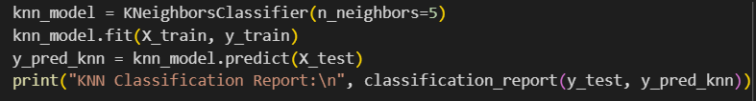

Naïve Bayes Model  
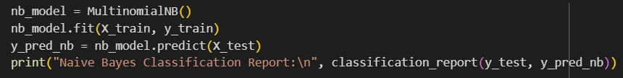

Random Forest Model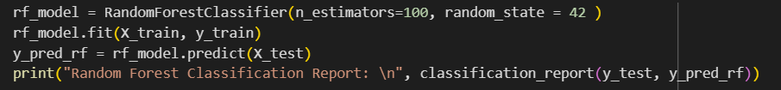

Logistic Regression Model  
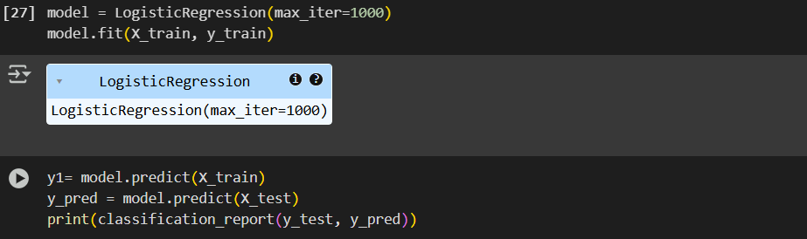

**Model Validation and Evaluation Report (5 marks):**

|  |  |  |  |
| --- | --- | --- | --- |
| **Model** | **Classification Report** | **F1 Score** | **Confusion Matrix** |
| KNN |  | 44.54% |  |
| Naïve Bayes |  | 66.11% |  |
| Random Forest |  | 76.92 |  |
| Logistic  Regression |  | 81.1% |  |